

**YEAR: 8**

**SEMESTER 2, 2017**

**SUBJECT: Science**

**NAME:**

**FORM:** **DATE:**

**Test: Body Systems**

**TIME: 50 minutes**

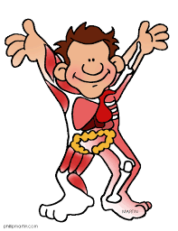

Total

**/60**

**%**

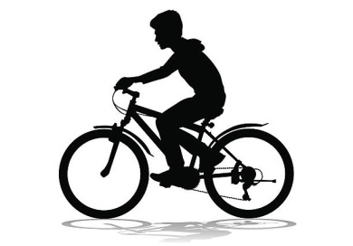

Simon rides his bike to school every morning. He notices that his breathing rate and heart rate change according to how fast he pedals.

1. Identify the body systems working overtime when Simon rides his bike. (2 marks)

1. What do you know about what’s in Simon’s blood? (10 marks)

1. Which organ causes Simon’s blood to be pumped around his body? (1 mark)

* 1. Draw and label a very simple diagram of this organ. (4 marks)
  2. Add arrows to your diagram to show the direction of blood flow

through this organ. (6 marks)

* 1. Shade and label each side of the organ to show the difference in the

type of blood present. (2 marks)

1. Explain how the blood is transported around Simon’s body. Describe the function and differences between the types of tubes that the blood travels through. (9 marks)

1. Circle and label the organs which are involved in helping Simon to **breathe**. (5 marks)

[1 mark will be deducted for labelling organs that do not help Simon to breathe]

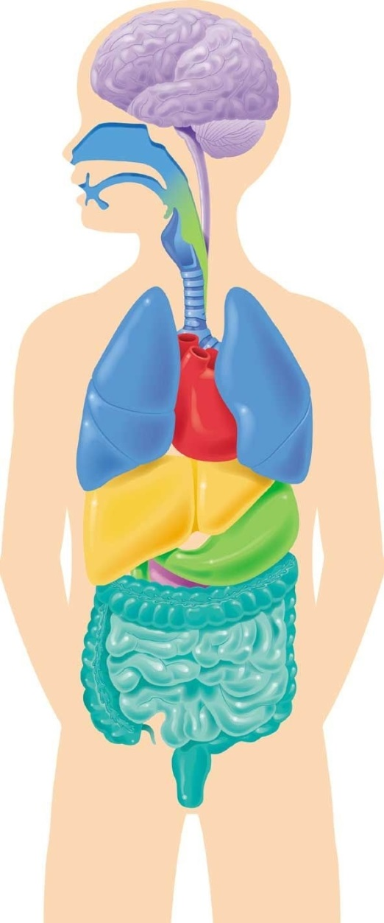

1. Explain how Simon breathes. (14 marks)

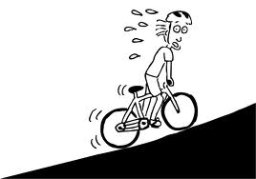On one particular morning Simon decides to take a short cut to school. The short cut that he takes involves a particularly high hill. At the top of the hill he notices that his breathing and heart rate are both much higher than they would be if he was riding on flat road.

1. Explain, using your best scientific knowledge, why **both** the breathing rate and heart rate increases during hard exercise. (7 marks)



**END OF TEST**

**Please check your work!**



**YEAR: 8**

**SEMESTER 2, 2017**

**SUBJECT: Science**

**NAME:**

**FORM:** **DATE:**

**Test: Reproduction and Survival**

**TIME: 40 minutes**

Total

**/10**

**%**

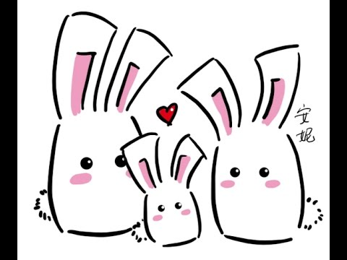

1. a) Label the two circles of the Venn diagram below indicating the **two main types of reproduction**.

(2 marks)

b) In the middle or overlapping section, list the **similarities** between the two types of reproduction.

(2 marks)

c) In the left and right sides, list the **differences** between the two types of reproduction. (6 marks)

1. 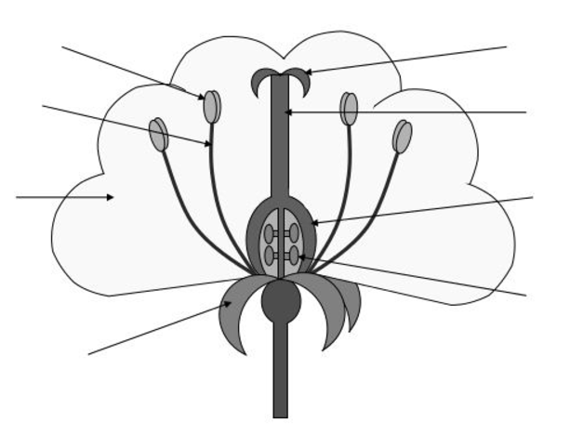Label the diagram of the dissected flower below to identify both the male and female reproductive parts. (8 marks)
2. a) Comparing the reproduction of humans and frogs, identify the different methods of **fertilisation** involved for each of these organisms.

b) Discuss the **advantages** and **disadvantages** of each of these methods.

1. Complete the following table about **asexual reproduction**:

|  |  |  |
| --- | --- | --- |
| **Type of asexual reproduction** | **Explanation of how it works** | **Example of an organism that uses this type** |
|  |  |  |
|  |  |  |
|  |  |  |
|  |  |  |

**Continue to next page**

During this module you prepared a PowerPoint presentation comparing two body systems of humans with those of different organisms.

1. Provide a short summary of what you know about the similarities and differences of body systems in different organisms. You may include labelled diagrams to help with your explanation.



**END OF TEST**

**Please check your work!**